Tech Blog Plan

Header
- Logo


- Website name
The Daily Tech

- Navigation menu
  - News
    - AI - 5
    - Business - 3
    - Mobile - 3
    - Computing - 3
    - Cybersecurity - 2
  - Reviews
    - Smartphones - 10
    - Laptops & PCs - 10
    - Tablets - 10
    - Gaming
  - Buying guides
    - Best Smartphones
    - Best Laptops
    - Best Tablets
    - Best Gaming
  - Companies
    - Microsoft - 1
    - Apple - 2
    - Samsung - 1
    - Google - 1
    - Meta
  - Entertainment

Homepage Layout
Top Stories (Top 5)
Featured Content (mix of news and reviews)

Latest News (display 3)

Latest Reviews (display 3)

Latest Buying Guides (display 3)

Article Layout
Sticky Navigation bar
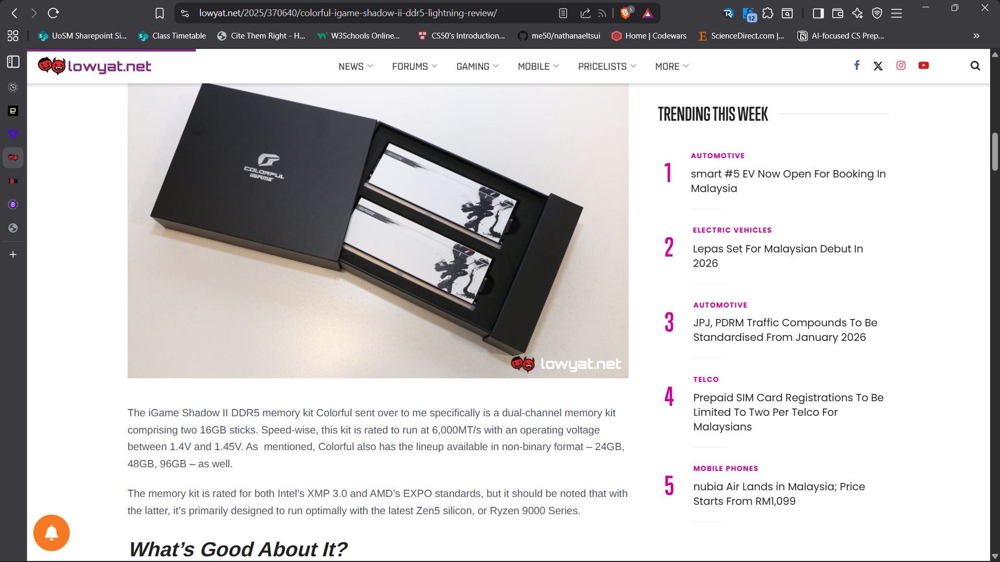

Sticky Side Bar (top stories)

Unique Page Layouts
- Home
- News
- News Category
- News article
- Reviews
- Review Category
- About
- Contact Us
- Buying guide
- Buying guide category

Articles
      - Social media flooded with OpenAI Sora 2 videos: AI-generated content draws concerns
(AI, Cybersecurity, OpenAI)
https://www.technewsworld.com/story/openais-sora-2-found-to-generate-false-claim-videos-80-of-the-time-179973.html
https://www.newsguardtech.com/special-reports/openai-sora-seeing-should-not-be-believing/
https://www.youtube.com/watch?v=2DhHxitgzX0
https://www.theguardian.com/technology/2025/oct/17/openai-sora-ai-videos-deepfake

      - AMD challenges Nvidia’s dominance with massive OpenAI deal
(AI, Business, OpenAI)
https://www.technewsworld.com/story/the-empire-strikes-back-how-amds-openai-deal-reshapes-the-ai-wars-179958.html
https://openai.com/index/openai-amd-strategic-partnership/

      - Solution to loneliness: emotional attachments to AI
(AI, Cybersecurity)
https://www.technewsworld.com/story/loneliness-love-and-llms-human-emotional-bonds-with-ai-179956.html
https://neurosciencenews.com/human-ai-emotional-bond-29186/

      - Nvidia and Intel’s partnership on AI Computing
(AI, Business, Computing)
https://www.technewsworld.com/story/a-new-era-nvidia-and-intels-alliance-for-ai-pcs-and-cloud-ai-179936.html
https://www.pcworld.com/article/2913861/nvidias-alliance-with-intel-signals-the-end-of-pc-graphics-as-we-know-it.html

      - Microsoft ends support for Windows 10: offers free extended security updates
(Computing, Microsoft)
https://www.engadget.com/computing/microsoft-has-ended-windows-10-support-but-heres-how-to-get-an-extra-year-for-free-125118044.html
https://www.lowyat.net/2025/369302/how-to-join-windows-10-esu-for-free/

      - Apple Unleashes M5 Chip: 4x GPU Performance of Its Predecessor
(Computing, Apple)
https://www.apple.com/newsroom/2025/10/apple-unleashes-m5-the-next-big-leap-in-ai-performance-for-apple-silicon/
https://www.engadget.com/computing/apples-m5-chip-pushes-ai-performance-with-new-neural-accelerators-193745702.html
https://9to5mac.com/2025/10/15/m5-vs-m4-whats-new-with-apples-latest-silicon/

      - Google Android PC: Attempt at Redemption After Chrome OS Failures
(Business, Computing, Mobile, Google)
https://www.windowscentral.com/microsoft/windows-11/google-is-building-the-android-pc-and-phone-convergence-platform-that-microsoft-failed-to-deliver-with-windows-qualcomm-calls-it-incredible
https://www.technewsworld.com/story/the-android-pc-googles-second-shot-at-the-unified-computing-dream-179947.html
https://www.theverge.com/tech/785351/google-reveals-its-android-for-pc-is-coming-next-year

      - Apple will reportedly use a custom version of Gemini to power the new Siri
(AI, Mobile, Apple)
https://www.engadget.com/ai/apple-will-reportedly-use-a-custom-version-of-gemini-to-power-the-new-siri-203046995.html
https://www.theverge.com/news/814654/apple-intelligence-google-gemini-ai-siri
https://www.reuters.com/business/apple-use-googles-ai-model-run-new-siri-bloomberg-news-reports-2025-11-05/

      - Samsung Plans ‘Health Hub’ To Connect Doctors With Patient Data
(Mobile, Samsung)
https://www.technewsworld.com/story/samsung-plans-health-hub-to-connect-doctors-with-patient-data-179792.html
https://www.lowyat.net/2025/356159/samsung-health-hub/
https://www.sammobile.com/news/samsungs-new-health-hub-will-let-you-easily-share-data-with-your-doctor/

      - AI Browsers are a Cybersecurity Time Bomb
(AI, Computing, Mobile, Cybersecurity)
https://www.theverge.com/report/810083/ai-browser-cybersecurity-problems

Footer
- About
- Contact Us

